1. Install nginx and run nginx on port number 81.

cat /etc/nginx/nginx.conf

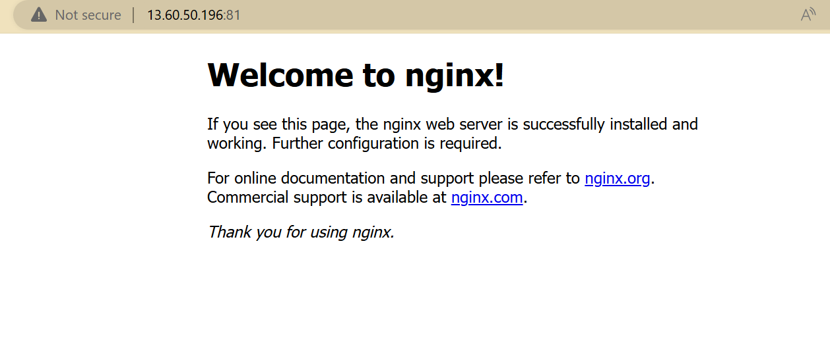

1. Deploy a sample index.html file on nginx.

cd /usr/share/nginx/html/



1. Install Apache and run Apache on port number 82

cd /etc/httpd/conf

1. Deploy a sample index.html file on Apache.

cd /var/www/html/

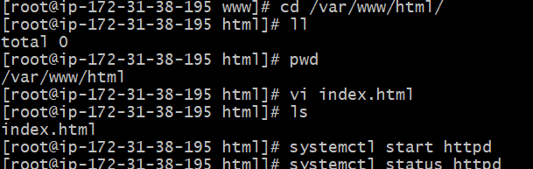

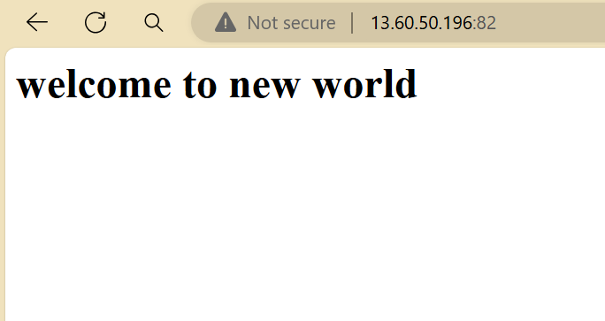

1. Install Apache tomcat on port number 8082

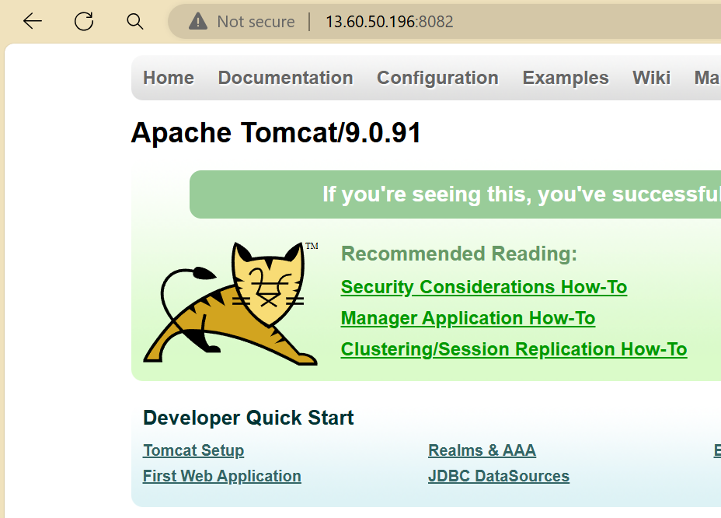

1. Deploy a sample app on webapps

[root@ip-172-31-38-195 webapps]# wget https://tomcat.apache.org/tomcat-7.0-doc/appdev/sample/sample.war

